

LeoEd AI: Your Personalized AI-Tutor
Breaking the traditional “one-size-fits-all” teaching model, LeoEd AI is an Adaptive Learning System (ALS) by using student performance data and study history to select appropriate topics, adjust quiz difficulty and provide focused adjustment. It integrates AI-assisted marking with a continuous feedback loop, allowing its recommendations evolve dynamically as new evidence about student understanding is collected over time.
Reliable AI Navigator | Personalized Learning Journey
Explore Platform 🚀Contact Us 🎓

Supported Subjects:

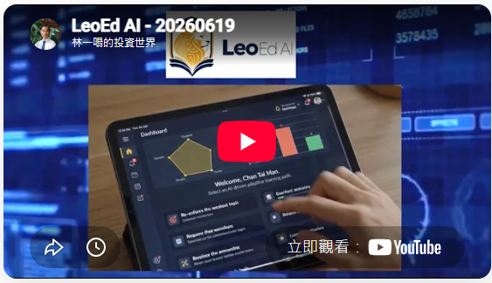

Adaptive Learning System
An adaptive learning system is a data-driven instructional platform that continuously analyses each learner’s performance and characteristics to deliver personalised content and feedback in real time.
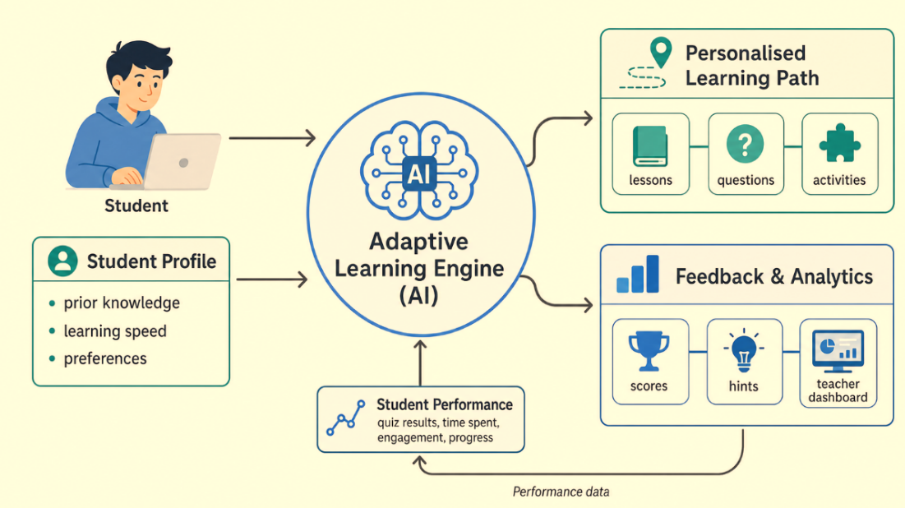

CORE PHILOSOPHY

Learn, Evolve, Optimize (學習、進化、優化)

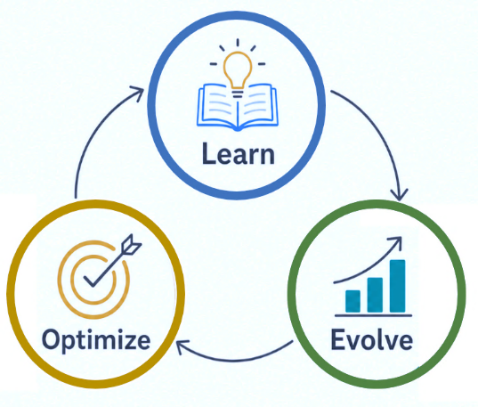
LEO stands for “Learn, Evolve, Optimize” (學習、進化、優化). This captures the full learning cycle that the system is designed to support:

Learn: Students learn new concepts through a personalized sequence of activities.

Evolve: The platform continually updates its database and learner model based on the student’s performance and progress.

Optimize: The system fine-tunes its recommendations to close the learning gaps and strengthen mastery.

POWERFUL TOOLS

Powerful AI Tools Transforming Modern Education

Adaptive Quiz Generation
Enjoy low-risk, high-frequency quizzes tailored for you. Our topic priority engine selects the most appropriate questions and calibrates difficulty based on student mastery, recent error rates, and forgetting risk.

Intelligent AI Grading
Get more than just a score. Our AI engine evaluates answers based on precise scoring criteria, providing detailed comments to explain scores, point out missing steps and conceptual misunderstandings, and offer specific improvement suggestions.

Multi-Modal Answer Submission
Submit assignments in the way that best suits the subject. Students can type text directly in the interface, use built-in tools to draw graphs and charts, or take photos of handwritten answers on paper and upload them.

Continuous Feedback Loop
Assessment results directly shape students' subsequent learning paths. Quiz results automatically update student profiles to recommend targeted review videos and adjust future quiz combinations.
SOLUTIONS & PIONEER SUBJECTS

Our Pioneer Products and Go-to-Market Roadmap
LeoEd AI is designed to support high-quality education across different subject areas through phased implementation.

University Accounting Course
Rule-Based AI Grading
Best first use case because accounting is rule-based with clear marking rubrics
Learn More

HKDSE Mathematics
Exam Preparation and Topic Mastery
Strong secondary-school market because Mathematics is a compulsory HKDSE core subject with broad student demand and a structured curriculum.
Learn More
Scale-up path
Large-Scale Exam Market Support
Expand to Gaokao preparation after pilot validation, which is a major long-term market with 13 million registered candidates per year.
Learn More
TRUSTED BY LEADERS

Our Partner Schools
Highly trusted and recognized by the education community.
Partner school information updating
PRICING REVOLUTION

Transparent, Flexible Pricing Plans
Pricing plans being adjusted, stay tuned
FOR EDUCATORS & INSTITUTIONS

Empowering Teachers, Building Smart Schools
Transform teaching from standardized instruction to a highly responsive, student-centered system.
📊

Granular Data Insights
Track student performance at the micro level and clearly understand learning gaps across the class.
⏰

Save Precious Time
Reduce the burden of heavy manual grading. Our AI can reliably assess open-ended questions and chart answers, allowing educators to focus on high-impact teaching and personalized support.
🎯

Data-Driven Decisions
Use actionable analytics data to provide targeted remediation or alternative explanations when students need them most.

Our Team
From Hong Kong Metropolitan University, specializing in speech and natural language processing technology.

Dr. Lam Yat Ming Eddie (林一鳴)
Founder
Assistant Professor, LSK School of Business & Administration,
Hong Kong Metropolitan University


Professor Fung Kwun Wing Joseph
Advisor
Professor, LSK School of Business & Administration,
Hong Kong Metropolitan University


Professor William YEOH Ging-sun
Advisor
Professor, LSK School of Business & Administration,
Hong Kong Metropolitan University

LeoEd
Smarter marking for teachers.
Deeper learning for students.
AI-powered teaching, making education a joy.

AI Zone

Resources

Contact Us
(852) 5601 0992
contact@leoedai.com
Book School Visit

© 2026 LeoEd Limited. All rights reserved.
Privacy PolicyTerms of Service

